Michael Osei

5/25/2023

COSC 480

User Registration Week 11

Login Page

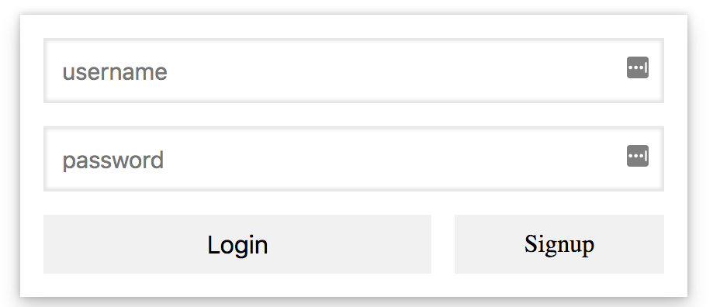

Sign Up page:

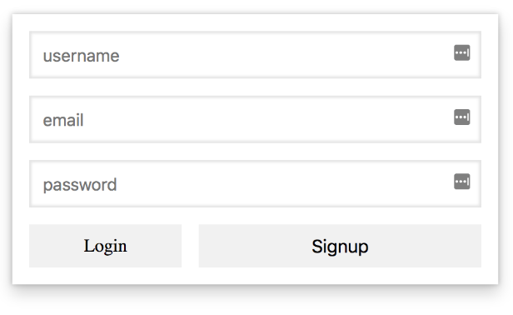

Logged In Page:

